M S Ramaiah Institute of Technology
(An Autonomous Institute, Affiliated to VTU) MSR Nagar, MSRIT post, Bangalore-54
A Dissertation Report on
Real time Response Capture and Analytics of Intelligent Tutoring System

Bachelor of Engineering in Computer Science & Engineering



DEPARTMENT OF COMPUTER SCIENCE & ENGINEERING

Under the guidance of:
Asst Prof Ganeshayya I Shidaganti

Submitted by:
Namratha Ravishankar 1MS11CS067
Ashwij S 1MS11CS152
Nuthana Kumari M 1MS12CS070
Aishwarya S S 1MS12CS142

1. Introduction

  - Modules …………………………………………………………… 2
  - Algorithm………………………………………………………….. 4
2.0 Architecture Design………………………………………………... 5
3.0 GUI………………………………………………………………… 6
4.0 Class Diagram……………………………………………………… 7
5.0 Sequence Diagram…………………………………………………. 8
6.0 Data Flow Diagram……………………………………………….... 9

Number of Modules

We have 5 modules:

- Registrations
- Login
- Video uploading
- Rating
- Performance analysis

Modules description

Registrations: User Registration (PUR) module allows users to register and access restricted content. You can use the module to register users for the Forum module and other custom modules that support personalization and user specific handling. For example, collect e-mail addresses of subscribers to a newsletter and allow them to manage subscription details after login

Login: After registration all users will can get a username and password. After login, server or admin will check the user entered username and password and compare to the database. If it is correct allow access to the next page else drop that request.

Video uploading: When staff wants to upload the video, the admin will check for the staff’s authentication and credential details. If it’s true then allow staff to upload the video. After uploading admin can publish video to student

Rating: After watching the video students will be able to give a feedback based on different criteria such as:

- Presentation Skills
- Syllabus Coverage
- Usage of Examples
- Understandability
- Practical Knowledge

Performance analysis: Access to analyze all individual sessions of tutors and also to compare the classroom sessions. The admins also should have a facility to save/send the graphs & csv files to files/emails.

Algorithm:

Admin Role:

Step 1: Registration of students by giving the details like student name, semester and year of studying
Step2: Once the students have registered they will get a login credential from admin
Step 3: Register the tutor’s with their personal details and provide login credential to each tutor
Step 4: Allocate the videos to each tutor in day basis
Step 5: Overall performance of the tutor and video wise performance are analyzed by the admin in the analyze session with the help of ratings given to different parameters such as Presentation skill, Practical Knowledge, Syllabus Coverage, Understandability, Usage of Examples
Step 6: comparison of video’s performance and staff performance is done by admin with the help of above said parameters
Step 7: Admin will send these performance reports to the Head of the institution through mail

Staff Role:

Step 1: Staff can analyze the rating points to improve their performance in their next session
Step 2: To better understanding staff can view their performance in video-wise method and over all method
Step 3: Ratings will be given at different times by the students. So to identify the proper result in this rating scheme aggregation and average calculation on rating points will be done by admin. Overall performance will be identified by taking average of given ratings to different parameters

Student Role:

Step 1: Students have to login with the given login credential
Step 2: Students have to select the video session based on the day
Step 3: From the available sessions, students have to pick any one session
Step 4: selected session will be playing with the help of media player on web page
Step 5: students have to give rating points based on the performance of the tutor on video
Step 6: students can give rating at any point of video
Step 7: at the end of the session students have to give their feedback on the video that they watched. At the same time they can view feedback of other students in the comment area.

2. Architecture Design

Student

Staff

Registration
login

login

Upload the video

Watch video
Give rating for full video

Analysis performance

admin
Get staff performance
Comparison result

3. Graphical User Interface

User Interfaces
- All the contents in the project are implemented using Graphical User Interface (GUI) in Java through JavaFX concepts.
- Every conceptual part of the projects is reflected using the JavaFX.
- System gets the input and delivers through the GUI
Hardware Interfaces
ISDN: We can connect AS/400 to an Integrated Services Digital Network (ISDN) for faster, more accurate data transmission. An ISDN is a public or private digital communications network that can support data, fax, image, and other services over the same physical interface. Also, you can use other protocols on ISDN, such as IDLC and X.25.
Software Interfaces
This software is interacted with the TCP/IP protocol, Socket and listening on unused ports. Server Socket and listening on unused ports and JDK 1.6. This software is also interacted with the SMTP protocol, sending and receiving on SMTP protocol.
Communication Interfaces
- TCP/IP protocol.
- SMTP.

4. Class Diagram and Classes

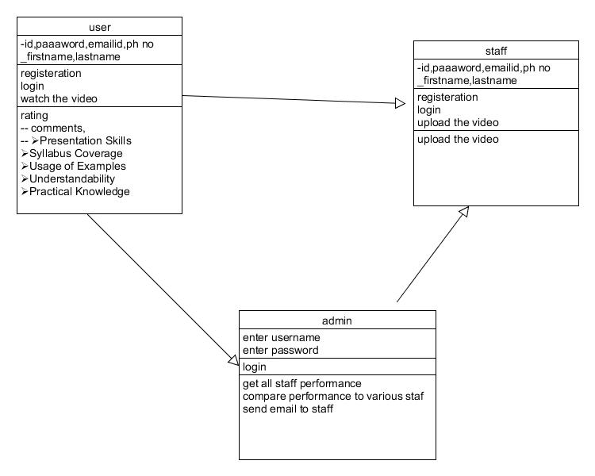

5. Sequence Diagram

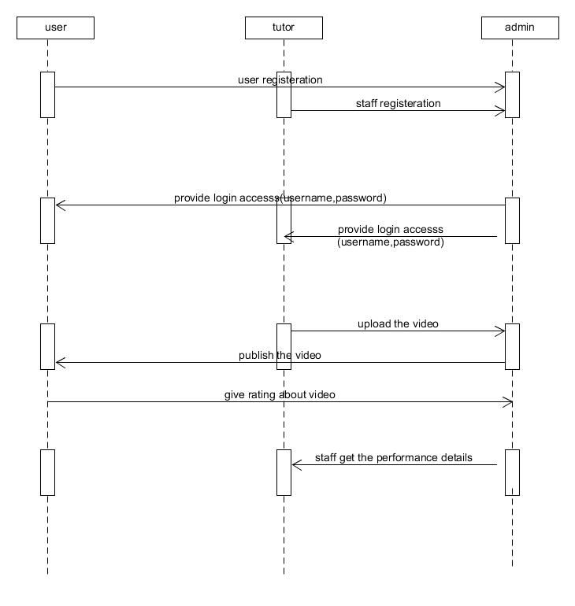

6. Data flow diagram

Student
Log in
Selection of day
Watching video
Rating the session
Feedback submissionnnnnnn

Staff
Log in
Select analyzing method
Selection of parameter
Viewing performance in graph

Video wise or overall
Admin
Log in
Select analyzing method
Selection of parameter
Viewing performance in graph
Selection of videos/staff to compare
Comparison
Reporting performance to head

